**Pressure measuring devices**

Pressure is defined as force per unit area that a fluid exerts on its surroundings. Pressure, P, is a function of force, F, and area, A:

P = F/A

A pressure measurement can be described as either static or dynamic. The pressure in cases with no motion is static pressure for example the pressure of the air inside a balloon or water inside a basin. Dynamic pressure is the pressure exerted on as surface because of a fluid moving past that surface it is exerted perpendicular to the direction of the flow.

A pressure measurement can further be described by the type of measurement being performed. The three methods for measuring pressure are absolute, gauge, and differential. Absolute pressure is referenced to the pressure in a vacuum, whereas gauge and differential pressures are referenced to another pressure such as the ambient atmospheric pressure or pressure in an adjacent vessel. 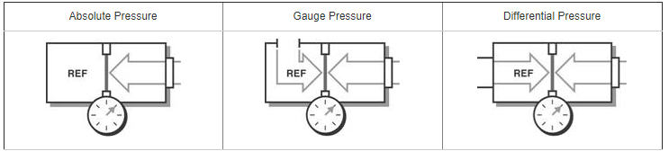

Many instruments have been invented to measure pressure, with different advantages and disadvantages. Pressure range, sensitivity, dynamic response and cost all vary by several orders of magnitude from one instrument design to the next. The oldest type is the liquid column (a vertical tube filled with mercury) manometer.

**Barometer**

Atmospheric pressure is measured by a device called a barometer; thus, the atmospheric pressure is often referred to as the barometric pressure . A frequently used pressure unit is the standard atmosphere, which is defined as the pressure produced by a column of mercury 760 mm in height at 0°C (  Hg = 13,595 kg/m3) under standard gravitational acceleration (g = 9.807 m/s2)

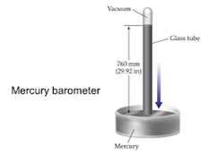This is a barometer of the mercury column type in which the diameter of the column is sufficiently small such that when the level changes, due to changes in atmospheric air pressure, the change in the level of the pool surface will be less than the accuracy within which conventional barometers can be read. Thus the scale opposite the top of the column does not have to be adjusted or ''''zeroed'''' to the pool level change.

Fig(1) Barometer

|  |  |
| --- | --- |
| **Disadvantages** | **Advantages** |
| Bulk and fragile glass tue | Too dense |
| Non-linear | has low vapour pressure |
| Require calibration | Inexpensive |
|  | No moving parts used |

**Deadweight tester**

Another type of mechanical pressure gage. It is used primarily for calibration and can measure extremely high pressures. A deadweight tester measures pressure directly through application of a weight that provides a force per unit area—the fundamental definition of pressure. It is constructed with an internal chamber filled with a fluid (usually oil), along with a tight-fitting piston, cylinder, and plunger. Weights are applied to the top of the piston, which exerts a force on the oil in the chamber. The total force F acting on the oil at the piston–oil interface is the sum of the weight of the piston plus the applied weights

A dead weight tester apparatus uses known traceable weights to apply pressure to a fluid for checking the accuracy of readings from a pressure gauge. A dead weight tester (DWT) is a calibration standard method that uses a piston cylinder on which a load is placed to make an equilibrium with an applied pressure underneath the piston. Deadweight testers are so called primary standards[citation needed] which means that the pressure measured by a deadweight tester is defined through other quantities: length, mass and time. Typically deadweight testers are used in calibration laboratories to calibrate pressure transfer standards like electronic pressure measuring devices.

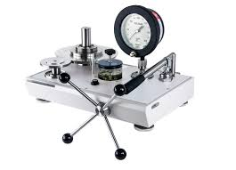

Fig(2) Deadweight tester

**Advantages:**  
it is simple in construction and easy to use.  
It can be used to calibrated a wide range of pressure measuring devices.  
Fluid pressure can be easily varied by adding weights or by changing the piston cylinder combination.

**Limitations:**

the accuracy of the dead weight tester is affected due to the friction between the piston and cylinder, and due to the uncertainty of the value of gravitational constant 'g'.

**Manometer**

A manometer is a scientific instrument used to measure gas pressures. Open manometers measure gas pressure relative to atmospheric pressure. A mercury or oil manometer measures gas pressure as the height of a fluid column of mercury or oil that the gas sample supports.

It is commonly used to measure small and moderate pressure differences. A manometer contains one or more fluids such as mercury, water, alcohol, or oil

How this works is, a column of mercury (or oil) is open at one end to the atmosphere and exposed to the pressure to be measured at the other end.Before use, the column is calibrated so that markings to indicate height correspond to known pressures. If atmospheric pressure is greater than the pressure on the other side of the fluid, air pressure pushes the column toward the other vapor. If the opposing vapor pressure is greater than atmospheric pressure, the column is pushed toward the side open to air.

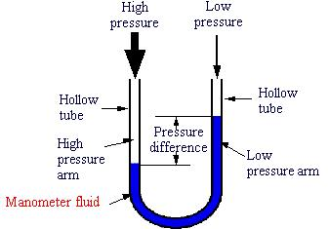

Fig(3) Manometer

|  |  |
| --- | --- |
| **Disadvantages** | **Advantages** |
| No electrical output | Linear |
| Poor sensitivity (gases) | No calibration required |
| Poor dynamic response | Good precision |
|  | Relatively inexpensive |

**References**

1)<https://www.ni.com/white-paper/13034/en/>

2) <http://www.rscal.com/perform-pressure-gauge-calibration-dead-weight-tester/>

3) <http://www.dictionary.com/browse/manometer/>